# **REST API with Flask, Docker, PyCharm, Postman and MySQL**

GitHub repository URL:

<https://github.com/Sowmyak91/RestAPIDockerFlaskPycharm>

1. postman listing all records for cities data

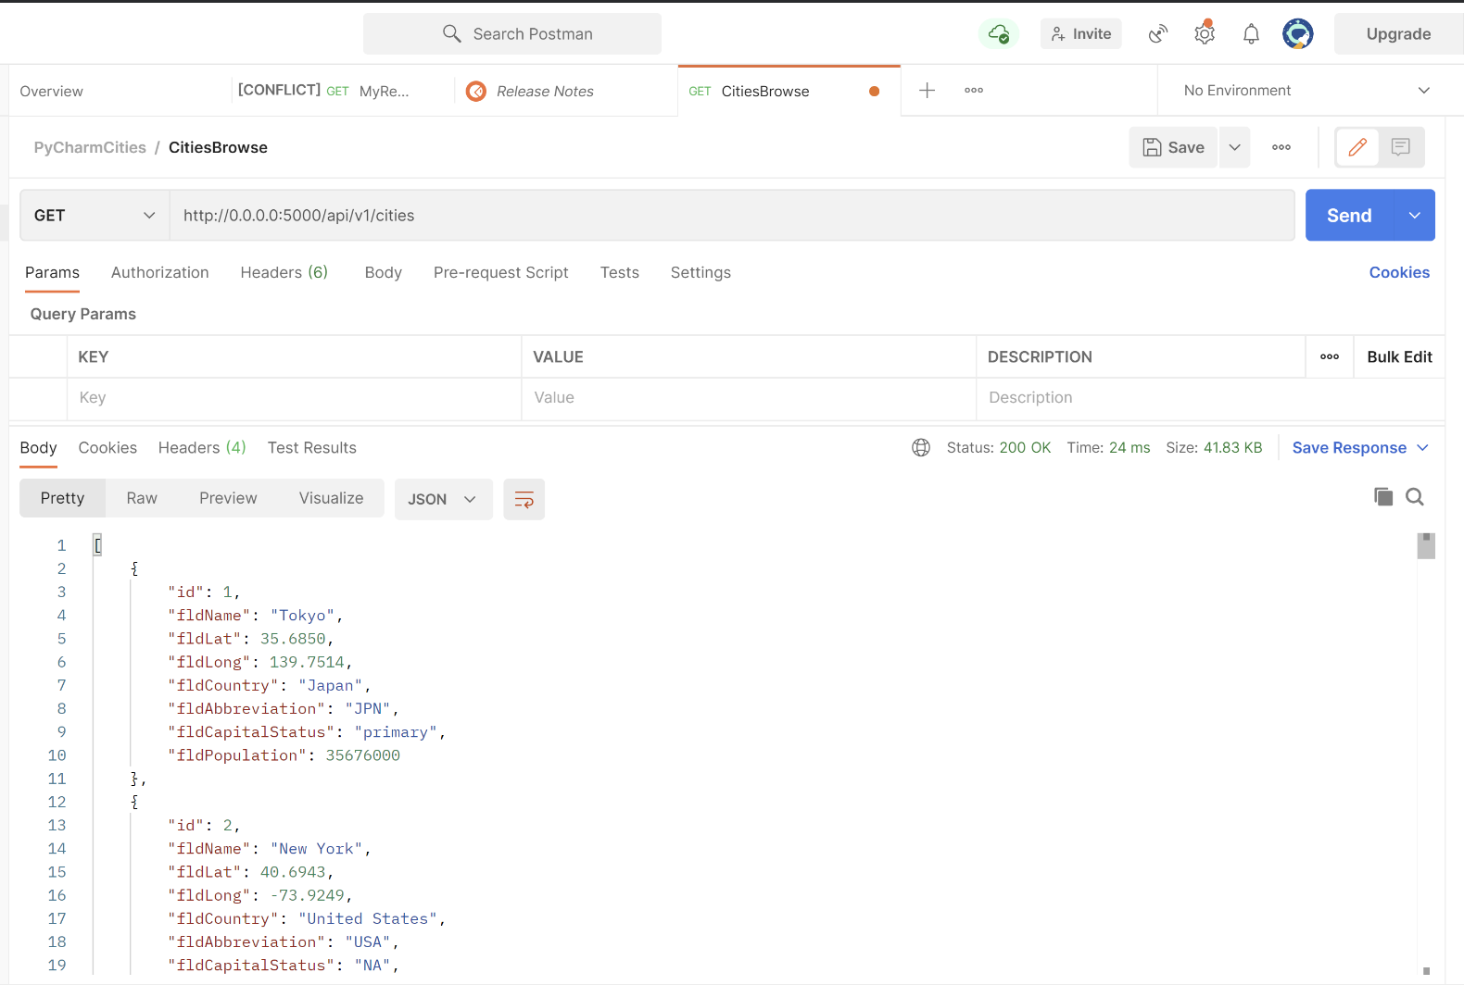

1. postman showing one record with a get request.

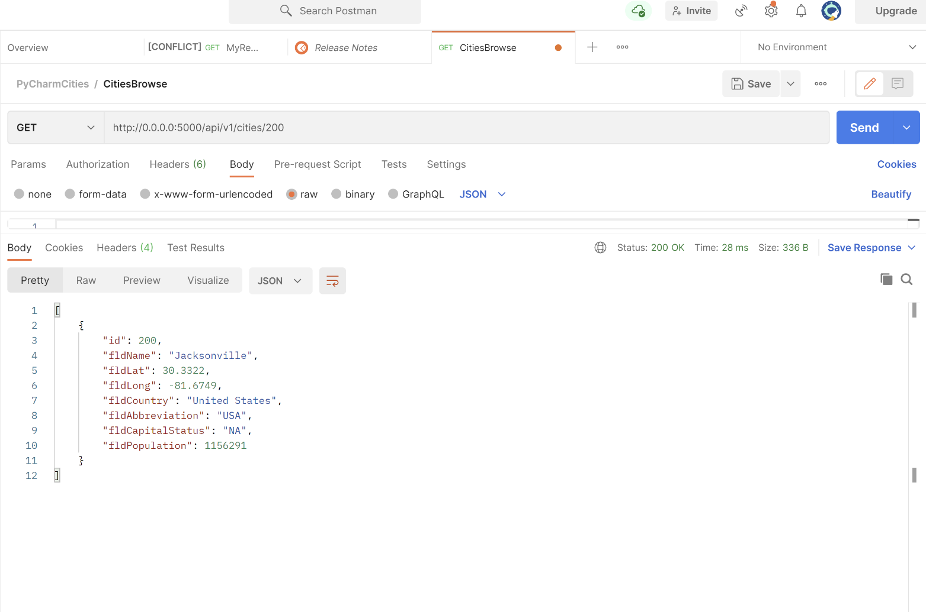

1. postman creating a record by showing the post request and the results in the record listing:

Created a new record using post request, with new name and country.

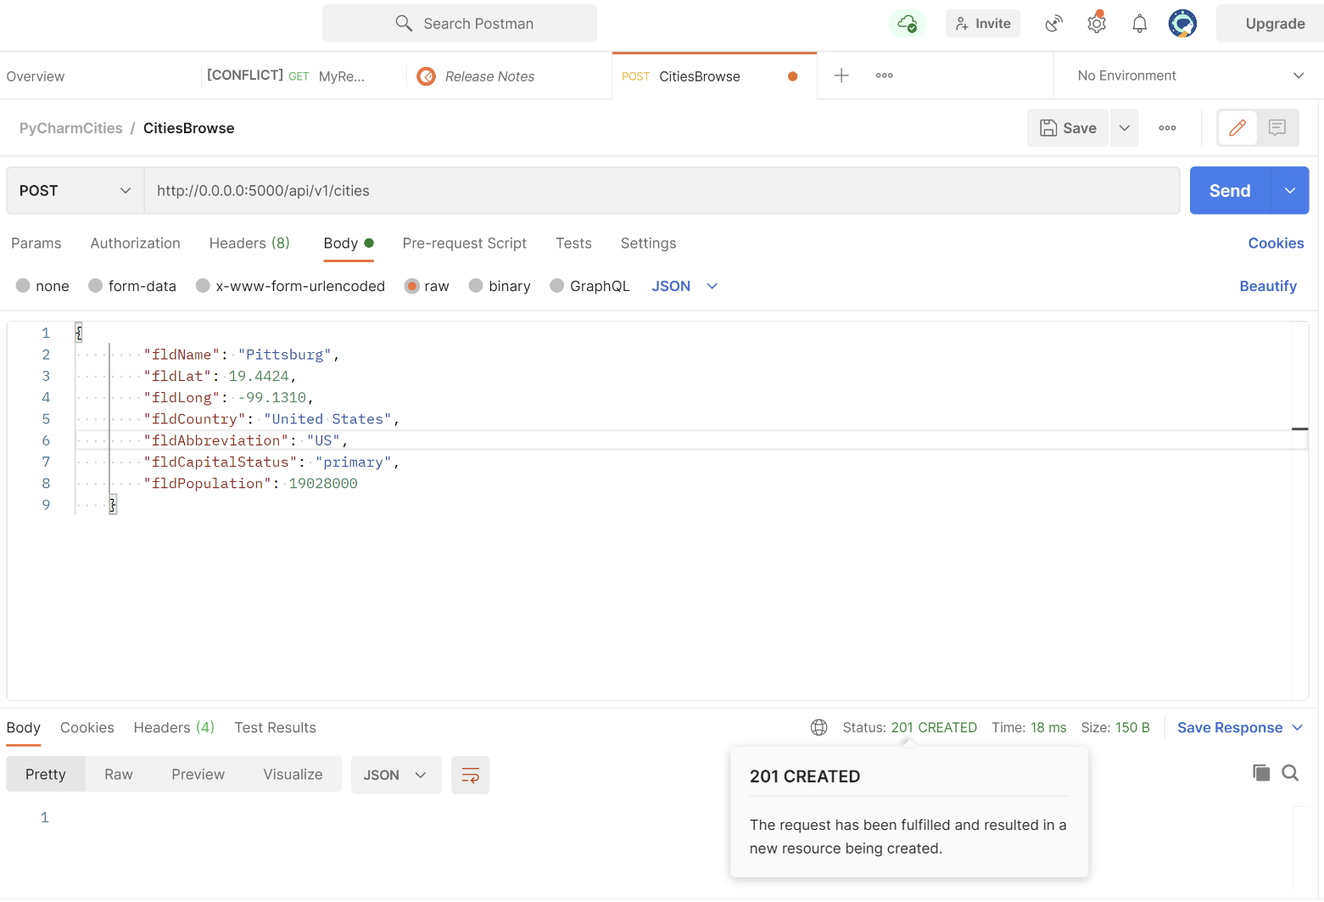

Results in record listing after adding new record using put request.

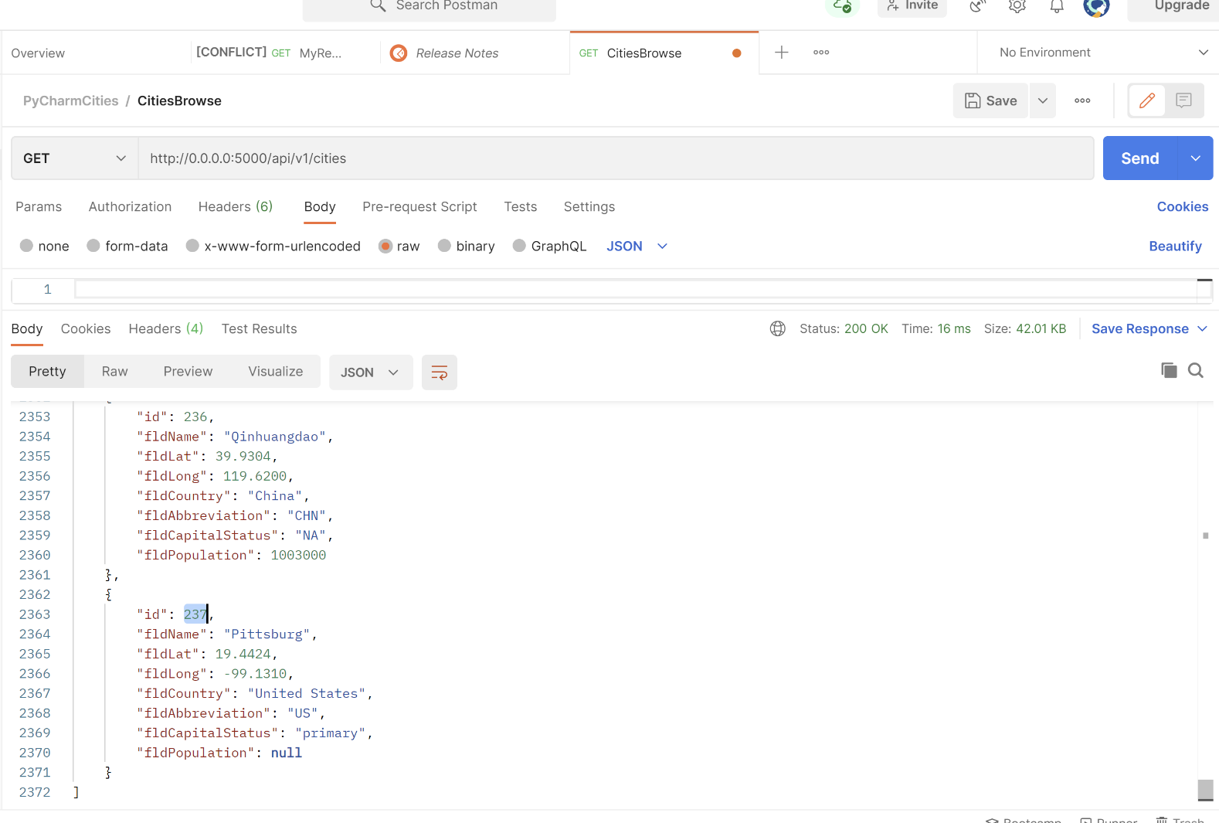

1. postman creating a record by showing the put request and the results in the record listing:

Edited the record using put request. fldPopulation is edited in the below record.

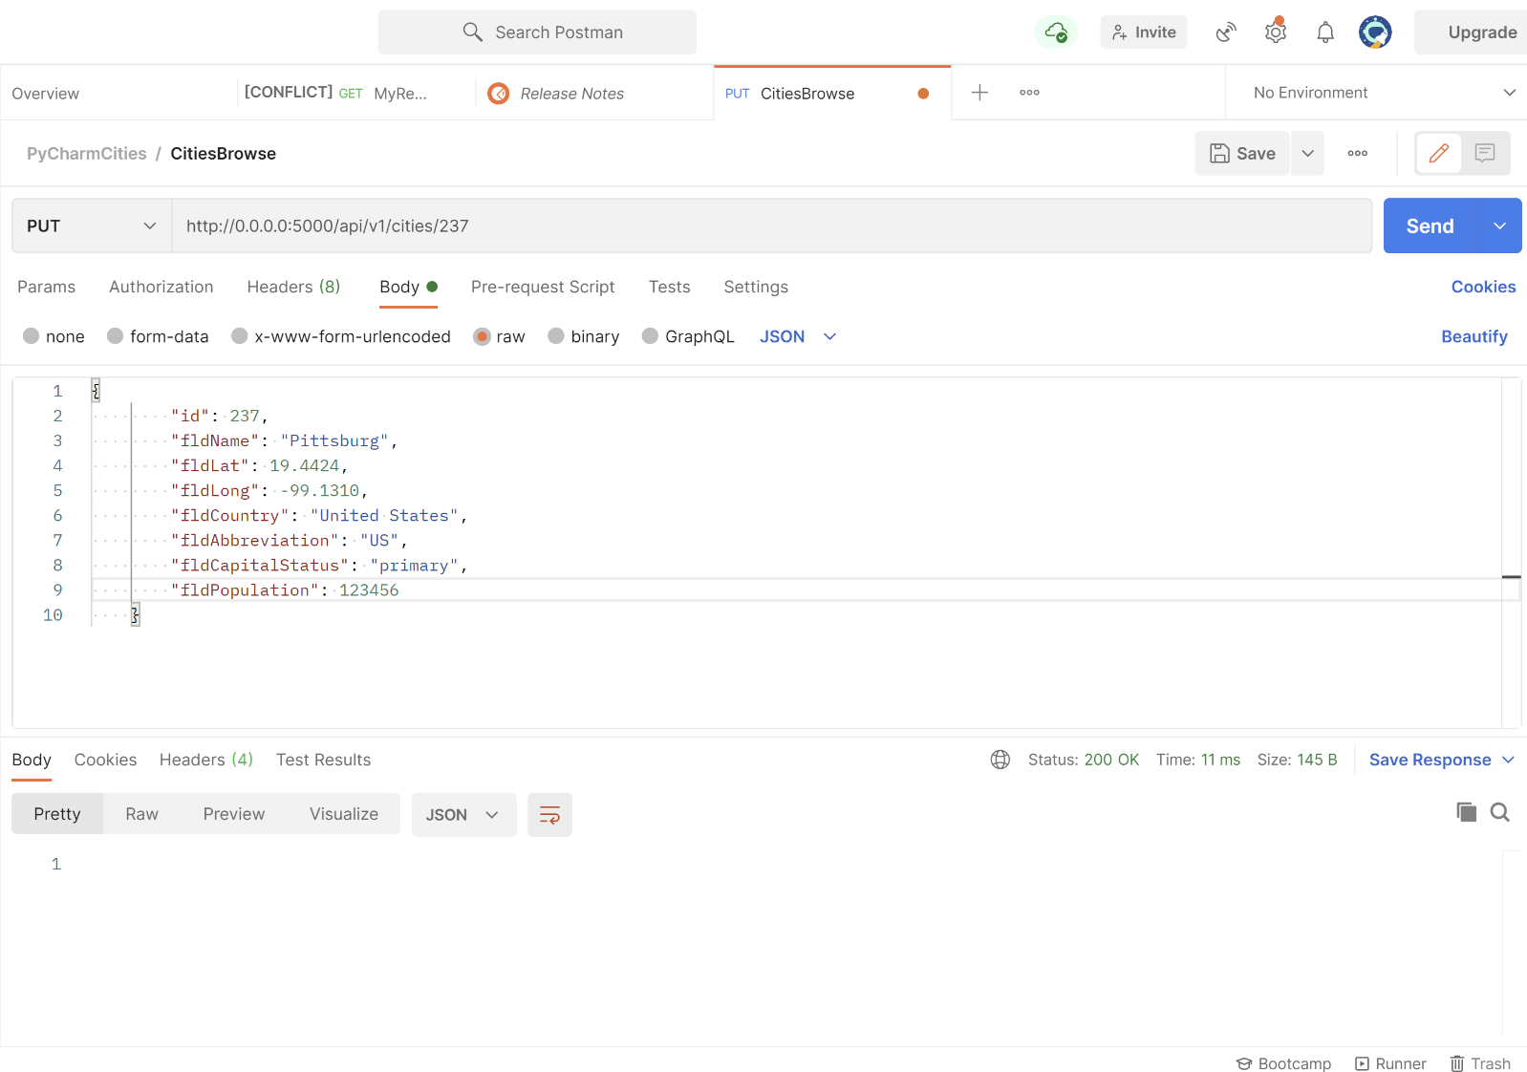

Results in the record listing after editing the record using put request

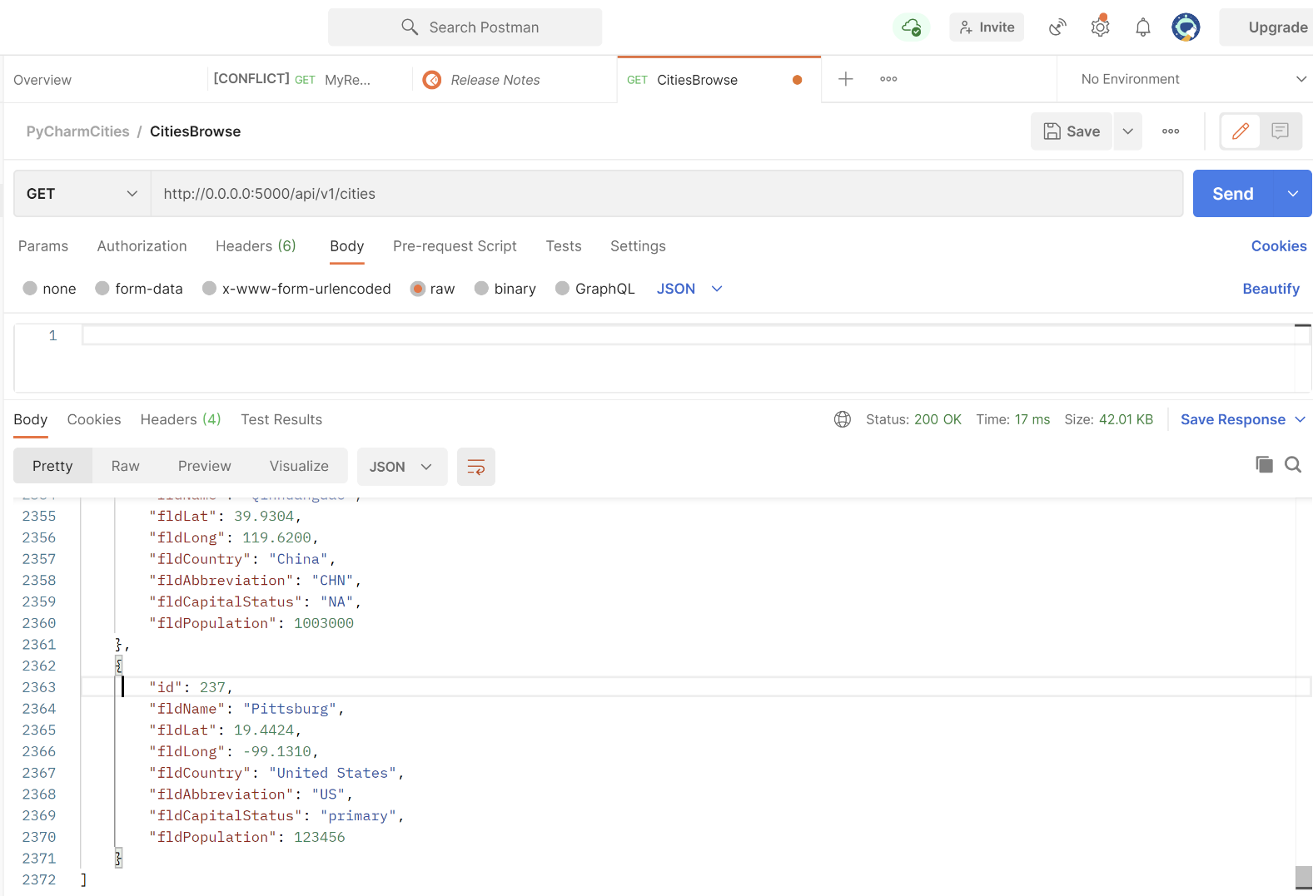

1. postman delete a record by showing the delete request and the results in the record listing:

Deleted record of id: 237 using delete request.

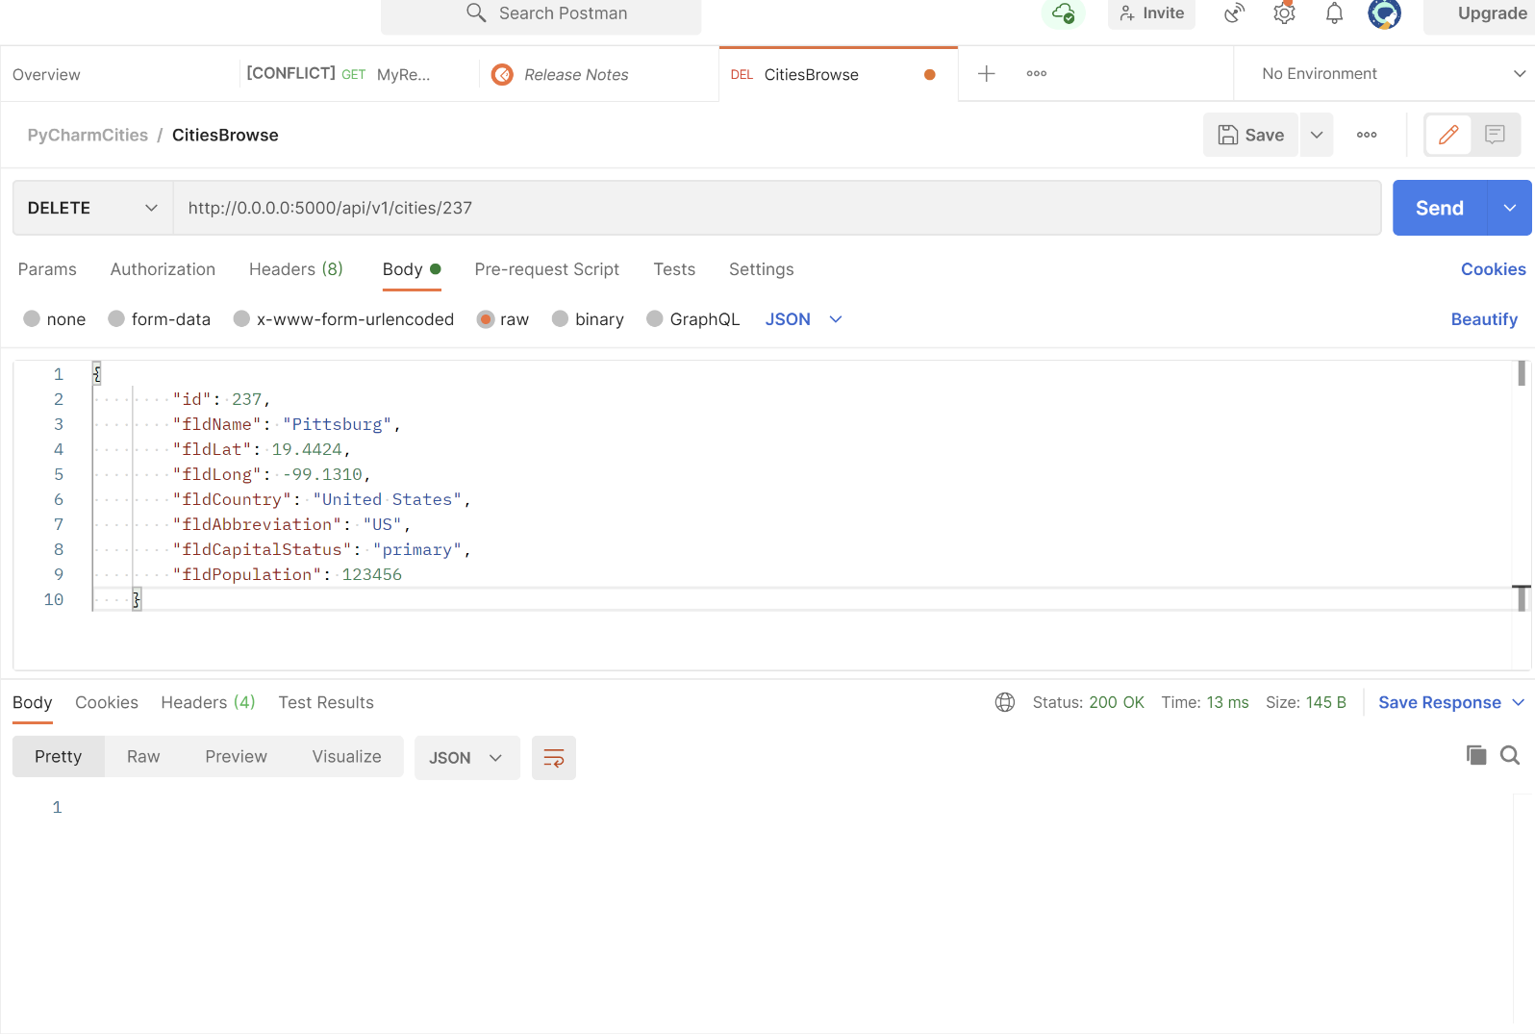

Results in the record listing after deleting the record using delete.

